How to make a pathway using PathVisio and WikiPathways
https://elixir.mf.uni-lj.si/course/view.php?id=24
Source: Department of Bioinformatics, Maastricht University, Maastricht, The Netherlands
Responsible: Friederike Ehrhart, Chris Evelo

Aim of the course: This course will enable you to draw a biological pathway for use in pathway analysis or visualisation of omics data.
Software used: PathVisio
Estimated duration: about 2h

Course outline
- Introduction
- WikiPathways Academy
- Support for do-it-yourself
  - PathVisio installation guide
  - Additional material

Introduction
Biological pathways are a series of chemical reactions (metabolic) or signaling events (signaling pathway) which controls homeostasis and directs signals within the cell. For a in depth introduction about what are biological pathways and why is it useful to analyse data (especially omics data) in the context of pathways have a look at this collection of lectures by the Canadian Bioinformatics workshops.
PathVisio is a software designed for making of biological pathways (and pathway analysis) (Kutmon et al. 2015). This course starts with a hands on tutorial at WikiPathways Academy. Then, it gives an installation guide to install PathVisio software, load the relevant mapping databases and some addons.

WikiPathways Academy
In this course you will learn how to make a pathway using the WikiPathways Academy online training. The WikiPathways Academy is a step-by-step tutorial on how to make pathways using PathVisio Software. These pathways can later be uploaded to the pathway repository Wikipathways. Start the course by following this link Wikipathways Academy and enter the WikiPathways Academy.

Biology 101. In the first module you will learn about the components of a biological pathway: gene products and metabolites.
Walk along a pathway. In this module you will learn how to “read” a pathway using the cholesterol biosynthesis pathway.
Pathway building blocks. In this module you will start drawing a the different components of a pathway: nodes (gene products and metabolites) and edges (conversion, catalysis etc.). For this you will be asked to start the web tool for PathVisio by “Launch Editor”.
My first metabolic pathway. This module will guide you through making a full pathway.
WikiPathways. This module shows you which steps need to be taken to upload your pathway to WikiPathways database to make it online available. It contains e.g. adding ontology tags, literature references and a description.
Setting pathway information free. In this model advanced information for proper “translation’ of figures into an interactive pathways is given and advice how to make a pathway “beautiful” by e.g. aligning stacks.

The QA protocol is not a part of the course. It is meant for WikiPathways developers and advanced users who would like to contribute in curation of WikiPathways database.

Support for do-it-yourself

PathVisio installation guide
In the WikiPathways Academy you used the webtool for PathVisio. Please find here the guide to install and run PathVisio on your own computer.

- Install PathVisio: PathVisio is open source free software available at www.pathvisio.org/downloads/. Download it and follow the installation instructions. PathVisio requires a Java environment pre-installed on the computer.
- Add WikiPathways plugin: For many applications PathVisio needs a plugin for WikiPathways which can be automatically downloaded and installed.
  - Open PathVisio - PlugIns - PlugIn Manager -
  - Choose WikiPathways plugin and click install.
- Add identifier mapping databases: On the PathVisio download page there is also a link to the "identifier mapping databases". These are needed to link the different genes and metabolites to their database identifiers.
  - Click "find the correct identifier mapping database"
  - Download from the Metabolite database "Metabolites (all species)" and from Gene product/protein database the species you need e.g. "Homo sapiens".
  - Unpack and save them in a folder.
  - Open PathVisio and go to Data
  - Select Gene Database
  - Browse to the folder where the gene product database file is stored and load it
  - Check the status bar at the bottom to see if the gene database has been loaded correctly.

Additional material
The YouTube channel of Alexander Pico containing several tutorial videos about making a pathway using PathVisio and several plugins.
PathVisio help pages
  - Documentation
  - Tutorials
Links to supporting material and documentation
  - Wikipathways papers How to cite Wikipathways
    - Slenter DN, Kutmon M, Hanspers K, Riutta A, Windsor J, Nunes N, Mélius J, Cirillo E, Coort SL, Digles D, Ehrhart F, Giesbertz P, Kalafati M, Martens M, Miller R, Nishida K, Rieswijk L, Waagmeester A, Eijssen LMT, Evelo CT, Pico AR, Willighagen EL. WikiPathways: a multifaceted pathway database bridging metabolomics to other omics research Nucleic Acids Research, (2017)doi.org/10.1093/nar/gkx1064
    - Kutmon M, Riutta A, Nunes N, Hanspers K, Willighagen EL, Bohler A, Mélius J, Waagmeester A, Sinha SR, Miller R, Coort SL, Cirillo E, Smeets B, Evelo CT, Pico AR. WikiPathways: capturing the full diversity of pathway knowledge Nucl. Acids Res., 44, D488-D494 (2016) doi:10.1093/nar/gkv1024
    - Kelder T, van Iersel MP, Hanspers K, Kutmon M, Conklin BR, Evelo C, Pico AR. WikiPathways: building research communities on biological pathways. Nucleic Acids Res. 2012 Jan;40(Database issue):D1301-7 (link to article)
  - PathVisio paper
    - Kutmon M, van Iersel MP, Bohler A, Kelder T, Nunes N, Pico AR, Evelo CT. PathVisio 3: an extendable pathway analysis toolbox. PLoS Comput Biol. 2015 Feb 23;11(2):e1004085. doi: 10.1371/journal.pcbi.1004085
  - Example workflow and applications
    - Martina Kutmon, Chris T Evelo, Susan L Coort. A network biology workflow to study transcriptomics data of the diabetic liver, BMC Genomics. 2014; 15(1): 971. doi: 10.1186/1471-2164-15-971
    - F. Ehrhart, S.L.M. Coort, E. Cirillo, E. Smeets, C.T. Evelo, L.M. Curfs. "Rett syndrome - biological pathways leading from MECP2 to disorder phenotypes." Orphanet J Rare Dis 11(1): 158. doi: 10.1186/s13023-016-0545-5
    - Nymark, Penny, Rieswijk, Linda; Ehrhart, Friederike; Jeliazkova, Nina; Tsiliki, Georgia; Sarimveis, Haralambos; Evelo, Chris; Hongisto, Vesa; Kohonen, Pekka; Willighagen, Egon; Grafström, Roland: A data fusion pipeline for generating and enriching Adverse Outcome Pathway descriptions. Toxicological Sciences, 2017 https://doi.org/10.1093/toxsci/kfx252

Quiz
- Which term is correct?
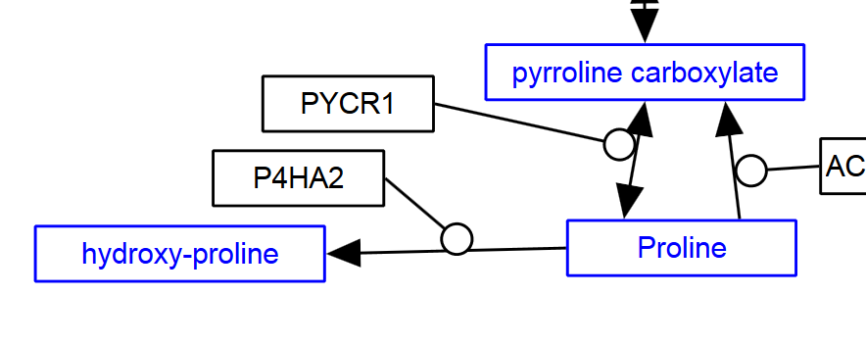
P4HA2 ……………… the conversion of proline to hydroxy-proline.
- Catalyses
- Stimulates
- Inhibits

(correct answer: a) )

2. Proline is a
- Gene product
- Protein
- Metabolite
- Interaction

(correct answer c)

3. A gene product can NOT be a
- Gene
- Transcript
- Protein
- Metabolite

(correct answer d)

4. Which MIM interaction is correct if you want to draw dopamine binding to a dopamine receptor?
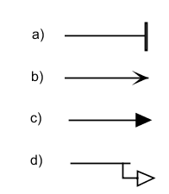

(correct answer: b) )

5. What makes WikiPathways unique as a pathway database compared to Reactome and KEGG?
- Visual representation of biological pathways
- Open license for complete database
- Collaborative modification of content
- Coverage of signaling and metabolic pathways
(correct answer: c)

